Having an unexplored occupancy grid, and a finite set of survey drones for conducting the exploration. The exploration process involves cooperation between the mothership and survey drones similar to what is described in “Multi-agent-based Auctions for Multi-robot Exploration” [1].

At start, a random survey drone is pointed as the first explorer, and is assigned a task to scan the initial cell, where the mothership is. Then the exploration is achieved iteratively by the mothership and survey drones following the algorithms below:

|  |
| --- |
| Survey drone:  Scan current cell;  Record *landFeatures(xcurrent , ycurrent  , features)* in memory;  Broadcast *explored(droneID , xcurrent , ycurrent , landFeatures)*;  Derive valid neighbors of the current cell;  For every valid neighbor:  Broadcast *unexplored(xneighbor , yneighbor)*;  Wait for incoming *ExploreQuest(x,y)*, when received:  Calculate the *utility* of doing *ExploreQuest(x,y)*;  If the *utility* is above a threshold  Respond back to the Mothership by *Propose(droneID,x,y,utility)*;  Wait for incoming *ExploreTask(droneID,x,y)*, when received:  If *droneID == myID*:  Move to the assigned cell;  Otherwise  Stay in current cell; |
| Mothership  Always listen and record for *explored(droneID,x,y,landFeatures)*, *unexplored(x,y)*, *Propose(droneID,x,y,utility)*;  Always record *landFeatures(x,y,features)*;  While *currentTime* % *contractInterval* == 0:  Calculate set *Boundary* = union of all *unexplored(x,y)*;  For each element in the *Boundary* set:  Broadcast *ExploreQuest(x,y)*;  While *currentTime* % *deadlineInterval* == 0:  Calculate set *Proposals* = union of all *Propose(droneID,x,y,utility)*;  For every distinct *(x,y)* in *Proposals*:  Find the proposal with the maximum *utility*;  Broadcast *ExploreTask(droneID,x,y)* with *droneID* in that proposal; |

The execution of these two would result in an exploration of the grid by iteratively pushing the boundary between explored and unexplored areas until the frontier of the forest is met.

Sequence diagram of communication:

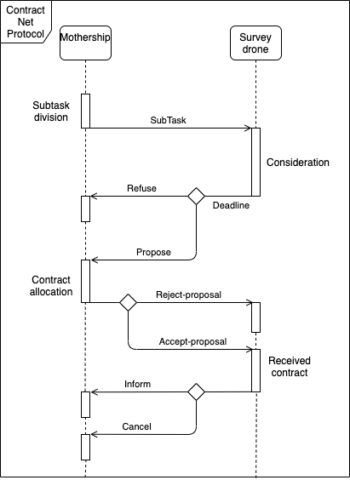

After the forest or the desired area is explored, the whole desired area, which is represented by a set of explored cells, is then recursively bisecting into subsets with sum of *potentialThreat* from each cells below a threshold, where *potentialThread* is calculated from the land features of each cell:

$potentialThreat =\frac{vegetationDensity}{humidity}$

The tasks of patrolling one of these subsets, *patrolTask(cells)* are then assigned to survey drones through a similar mechanism as described in the exploration.